THE ELMS MEDICAL PRACTICE

Winter Newsletter 2023

In this edition
Staff News
Elms News
Clinical Update
NHS App
Triage System

Recipe corner:
Healthy Winter Warmer Soup

Management Changes

In September we wished our Practice Manager of the last 14 years, Sarah Brindley a happy retirement. Sarah started at the Elms in 1997 as IT support, rising through the ranks to the top where she was the Elms figure head for many years.
In the same breath though, we are happy to say that our previous assistant manager, Emma Heaton, now takes the reins, leading us on to a bright future. Emma has been with the Elms for 14 years starting as admin support for the ENT service, let’s see if she can break Sarah’s record.
Training and Staff News

As a training surgery we are delighted to support training doctors as they work to qualify in their chosen specialty. All learners and registrars are always fully supported by an established GP.
We recently welcomed two Cambridge Students Sohaib and Despina who will be sitting their final exams next month We wish them well in their future careers.
We were also delighted to welcome back Dr Roshni Patel who is joined by Dr Yonis Elmi. Both doctors are in their final year of qualifying as GPs and are already a great addition to the Elms Surgery team.
The clinical nursing team are also looking forward to working with Aisling O’Connor. Aisling is an experienced nurse who will work alongside our existing nurses to provide extra treatment room support.
And finally, welcome to Cathy, who recently joined our prescribing and admin team replacing Millie who is developing her career in podiatry (you may see her whizzing around in her “Fresh Feet” Mini.)
Many congratulations to Dr Bhardwaj and his family who recently welcomed a baby boy.

Clinical Updates

Over 65 years, pregnant, medically at risk? There is still time to have your flu vaccination. Please contact us via our online form to arrange an appointment.

NHS APP

The NHS App launched in 2019 but are you aware of what the NHS App can do? Many patients downloaded the App to use as proof of COVID vaccinations for
travelling. However, the app can actually do a LOT more than this. Firstly, if you have your notifications turned ON, if the practice contacts you, you will get this message quicker through the NHS App rather than waiting for a text or email. Get your notifications switched on now!
Secondly, did you know the NHS App can save you time? For example, when requesting a prescription all you need to do is confirm your pharmacy and click on the prescription items you require from your repeat list. The NHS app already knows it is you, so you don’t need to confirm this again. You can also use it to complete an online consult by using ‘view my messages’ and then selecting on ‘Ask your GP surgery a question’. This then tells you it is taking you to Accurx – which is our online provider. However, it will FILL IN YOUR DETAILS for you as it links together. Thus saving you time putting in your details every time and using confirmation codes to confirm it is you.
Go on – give it a try!

Triage System

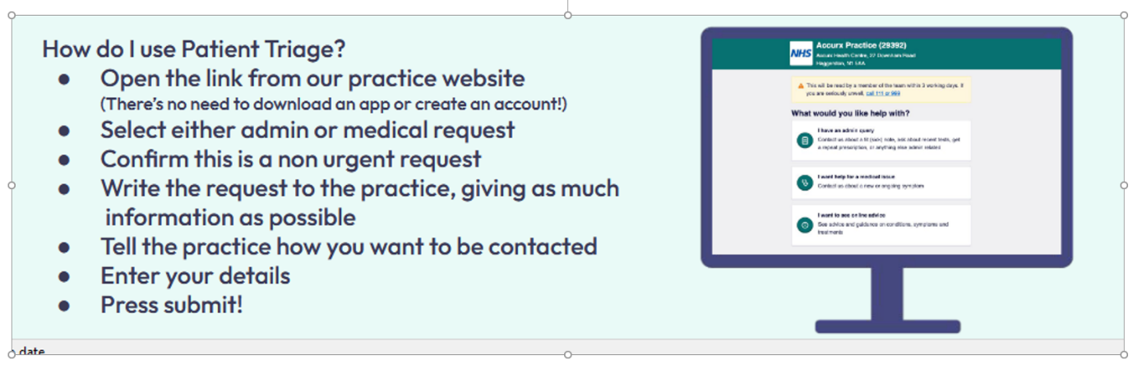

It is now just over 2 months since we changed the way patients access the practice. We are delighted that overall, the system is working well for both patients and the practice. We have been overwhelmed by the amount of positive feedback we have received, and most of all, the improvement to the patient journey. Of course, nothing is perfect, and we are continually making improvements and reviewing the system to provide the best service we possibly can.

Please remember that if you are unable to access the internet or complete a form, you can telephone us and a receptionist will complete the form on your behalf.

Recipe Corner

Curried Cream Parsnip Soup:
With Winter on the way and Christmas round the corner I thought a nice healthy hearty soup would be quick and easy to make. I have to say, I like a soup that is HOT and spicy, so be aware when making this add as much or as little of the curry powder/paste as you like.

You will need:
X5 large parsnips (skin on)
X1 small white onion diced.
X2 Vegetable stock cubes.
Curry Powder/paste to taste.
Cream/Creme Fraiche/Greek Yoghurt (to splosh)

Method:

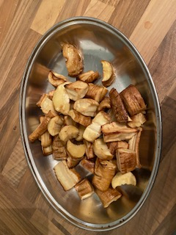
Firstly, top and tail your Parsnips and give them a good wash under cold water, chop them into discs and place in an oven proof/air fryer dish with a little oil and rub in. Place in your mode of cooking until golden brown but not over cooked
In a pan place x3 pints of water and two stock cubes and bring to the boil, making sure the cubes are dissolved.
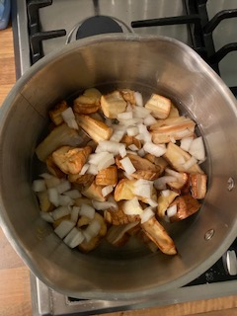
Add to this your diced onions and roasted parsnips and turn down the heat, simmer for about 10 minutes until the onions are opaque then add your curry powder/paste and simmer for another 5mins, to cook out any bitterness if using curry powder.

Take off the heat and leave for a minute, then blitz with a hand blender. You can use a food processor but let the liquid cool a little so that you can transfer it easily without burning yourself.
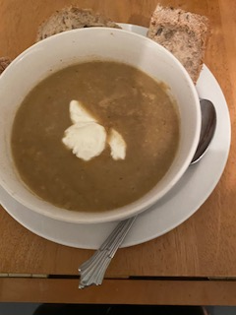
Ladle a ‘large’ portion into a bowl with a splash of Cream (or as above, Greek Yoghurt) serve with crusty sour dough bread, or whatever takes your fancy, Yum.

